Manufacturing & Assembly Time, Labour Cost and Sustainability Assessment
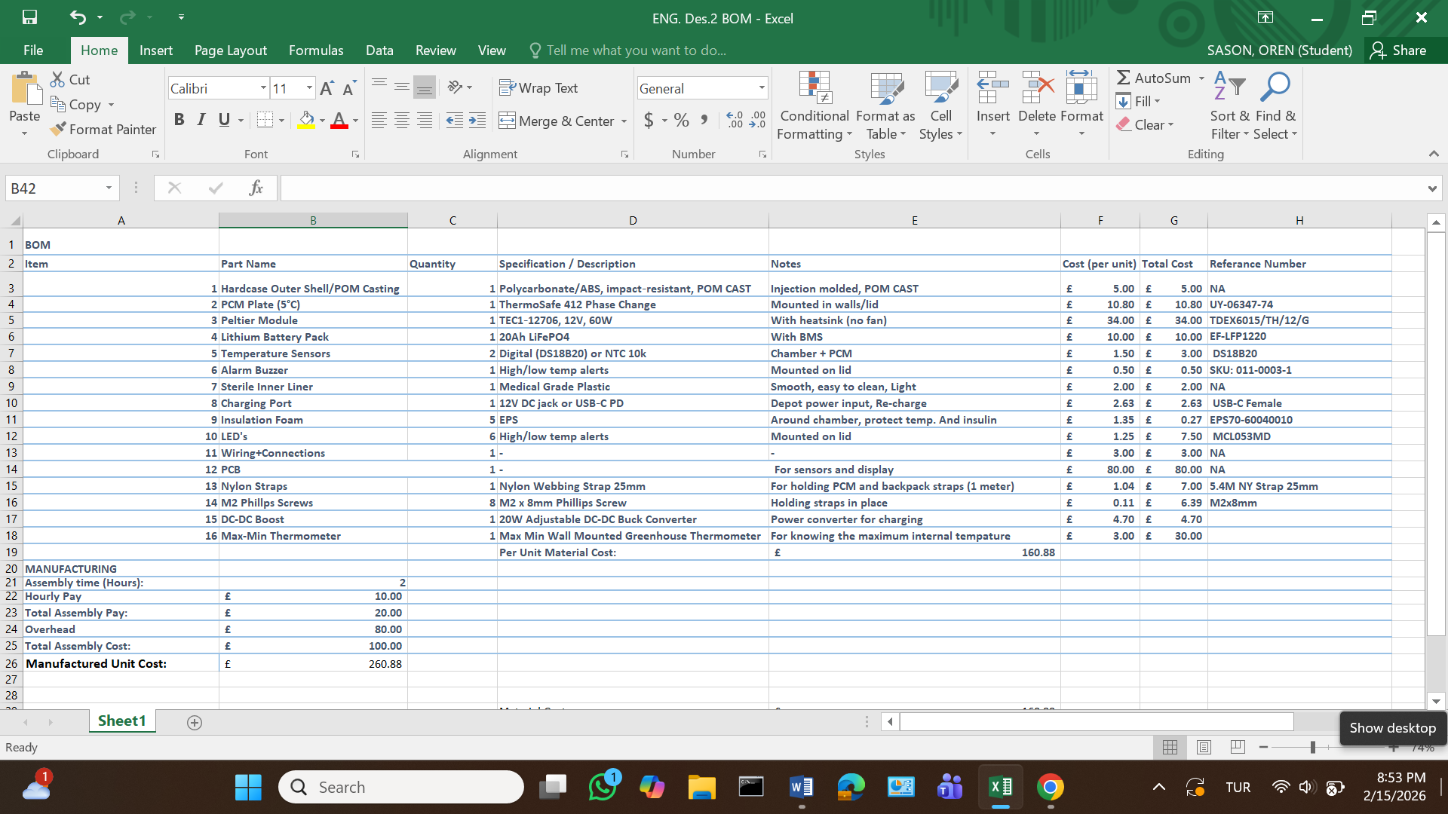
Figure 1; BOM and Manufacturing Price Lists
Assembly Time Breakdown (per unit)
Task Times;
Casing prep + insulation 20 min
PCM installation 10 min
Peltier mounting 20 min
Battery + wiring 25 min
Sensors, LEDs, buzzer 20 min
Final assembly 15 min
Testing (parallel batch) ~10 min
Total hands-on time ~2 hours / unit
To cost this labour, we reference publicly available wage data for comparable roles. In China, basic electronics assembly wages range around (~£4–£6) per hour for factory assembly work, consistent with industry salary reports for assemblers and production technicians (see https://www.salaryexpert.com/salary/job/electronics-assembler/china). By contrast, wage data for Libya is less formally published, but broader salary surveys indicate average pay levels are significantly lower than in China (see https://remotepeople.com/countries/libya/average-salary/).
Because the assembly work involves only basic technician skills and light soldering it is technically feasible to train local assemblers in Libya with short focused training (1–2 weeks). For total efficiency and scale, purchasing components from China and then performing final assembly and quality testing in Libya minimizes landed costs and reduces shipping volume while creating local economic value.

Why Libya is More Sustainable
Local assembly in Libya is considered more sustainable this is due to reduced transportation emissions, improved product lifespan, and local repair capability. Shipping fully assembled units from China requires transporting large volumes of air-filled casing, insulation, and packaging over long distances. By contrast, shipping compact sub-assemblies and completing final assembly in Libya significantly reduces shipping volume and associated CO₂ emissions per unit.
In addition, assembling the product locally enables on-site maintenance, repair, and component replacement. Failed components such as batteries, peltier modules, or fans can be replaced locally rather than discarding the entire unit, extending product lifespan and reducing electronic waste. This is particularly important in Libya, where recycling infrastructure is limited but repair culture is very strong.
The total assembly labour cost is £20 combined with overhead of £80 per unit, results in an overall manufacturing cost of £260.88 per unit.

